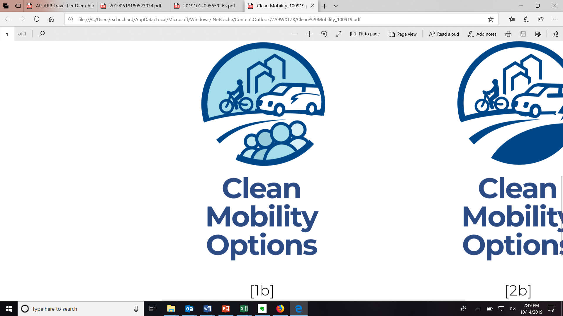

**CMO Implementation Manual Changes: FY 2020-21**

The FY 2020-21 Implementation Manual (IM) for the Clean Mobility Voucher Pilot Program (CMO) was published on September 9, 2020. This version of the IM applies to voucher applications submitted on or after October 20, 2020, and addresses other general policy changes and clarifications.[1] The IM is published at <https://www.cleanmobilityoptions.org/implementation-manual/>.

For more information and specific questions about a voucher application in progress, please contact [info@cleanmobilityoptions.org](mailto:info@cleanmobilityoptions.org).

**Summary of Key Updates:**

* Clarification that local special purpose districts such as school districts or library districts can apply independently of the city or county with which they are associated.
* Clarification that individual departments within an agency (such as a City Transportation Department), or individual facilities within a special purpose district (such as a library or school), can participate with their governing agency or district as the lead applicant. They are not considered distinct applicants from their governing body.
  + Page 10 (Mobility Project Voucher)
  + Page 56 (Needs Assessment Voucher)
* Certain non-profits that are tribally chartered corporations under tribally enacted laws may be exempt from registration with the California Secretary of State.
  + Page 11 (Mobility Project Voucher)
  + Page 57 (Needs Assessment Voucher)
* Clarification that for the purpose of providing a letter of support from a project-related community-based organization (CBO) or local community group, the CBO or local community group must meet a minimum of two of the criteria listed. The letter of support from CBO must also demonstrate how the CBO meets these criteria.
  + Pages 11-12 (Mobility Project Voucher)
  + Pages 57-58 (Needs Assessment Voucher)
* Clarification that public agencies are not considered CBOs.
  + Page 12 (Mobility Project Voucher)
  + Page 58 (Needs Assessment Voucher)
* Clarification that tribal land is not considered an unincorporated community.
  + Page 12 (Mobility Project Voucher)
  + Page 58 (Needs Assessment Voucher)
* Sub-applicants may be unincorporated non-profit organizations. If the sub-applicant is an unincorporated non-profit, they must have a contract with a fiscal sponsor who is tax-exempt with the Internal Revenue Service under Internal Revenue Code Section 501 and tax-exempt under California state law. The fiscal sponsor must also be registered and in active/good standing with the California Secretary of State to perform financial management and administrative functions for them on behalf.
  + Page 12 (Mobility Project Voucher)
  + Page 57 (Needs Assessment Voucher)
* If the entity applying for the Needs Assessment Voucher is an unincorporated non-profit or is not registered with the California Secretary of State at the time of application submittal, they must utilize an eligible fiscal sponsor to serve as a lead applicant and conduct financial management and administrative functions for them on their behalf.
  + Page 58
* Clarification that food and childcare costs associated with events are not reimbursable expenses under the Mobility Project Voucher or the Needs Assessment Voucher.
  + Page 20 (Mobility Project Voucher)
  + Page 65 (Needs Assessment Voucher)
* Fuel and electricity costs are added as eligible expenses in the Mobility Project Voucher.
  + Page 21
* Community Resource Contributions may include revenue from credits generated by the Low Carbon Fuel Standard (LCFS) that will be used during the Voucher Funding Term.
  + Page 38
* Non-profit organizations must submit documentation of their legal status with their application, as follows:
  + **Copy of the IRS Determination Letter** as evidence of their tax-exempt status with the Internal Revenue Service under Internal Revenue Code Section 501.
  + **Copy of Exemption Letter from State of California Franchise Tax Board** as evidence of their tax-exempt status under California State law.
  + **Copy of Articles of Incorporation** as evidence of at least one-year incorporation from the time of voucher application submission.
  + **Copy of Statement of Information and Certificate of Status** as evidence of being registered and in active and good standing with the California Secretary of State.
  + Page 40 (Mobility Project Voucher)
  + Page 67 (Needs Assessment Voucher)
* Application Submission: Removal of in-person application delivery. Only email and post-mail application delivery methods are now accepted.
  + Page 41 (Mobility Project Voucher)
  + Page 68 (Needs Assessment Voucher)
* Application Evaluation: Time period between application submittal and confirmation of receipt by Program Administrator is changed from two days to five days. Time between application submittal and status notification from Program Administrator is changed from one month to six weeks. The submission period for minor corrections or clarifications requested by the Program Administrator during application screening period is changed from five business days to five calendar days.
  + Pages 41-42 (Mobility Project Voucher)
  + Page 69 (Needs Assessment Voucher)
* A process is established for applicants to notify the Program Administrator if they wish to withdraw their application after submittal.
  + Pages 42-43 (Mobility Project Voucher)
  + Page 70 (Needs Assessment Voucher)
* Clarification that a certificate of insurance and a payment milestone schedule are also required voucher execution documents for tribal applicants.
  + Page 45 (Mobility Project Voucher)
  + Page 72 (Needs Assessment Voucher)
* Community Transportation Needs Assessments developed with Needs Assessment Vouchers may address transportation solutions beyond those eligible for CMO Mobility Project Voucher funding.
  + Page 56
* Clarification that the Needs Assessment Voucher recipients cannot use the same resident survey conducted for the transportation access data analysis to fulfill part of the requirement for minimum of two community engagement types.
  + Page 62
* A funding set-aside was established to reserve Needs Assessment voucher funding for tribal applicants, and a process was established for reallocating set-aside funds if they are unclaimed by tribal applicants.
  + Page 69
* Liability insurance requirements for Mobility Project Voucher recipients are updated to require limits not less than $5,000,000 per occurrence for bodily injury and property damage liability combined with a $5,000,000 annual policy aggregate. Voucher agreements may be terminated if certificates of insurance are not produced by voucher recipients upon request.
  + Page 82
* For projects with electric bicycles or scooters, specific insurance coverage must be obtained for use of this equipment. Options for compliance with this requirement are described.
  + Pages 83-84
* Sectarian Organizations and Non-Public Schools Restrictions: Awardees are prohibited from using voucher funds to aid or support a sectarian purpose pursuant to California Constitution, article XVI, section 5. Awardees are also prohibited from using voucher funds to aid or support a sectarian or denominational school or any school not under the exclusive control of the officers of the public schools pursuant to California Constitution, article IX, section 8. CARB and the Program Administrator reserve the right to obtain additional information from applicants and voucher awardees to determine compliance with California Constitution, article XVI, section 5 and article IX, section 8. Failure to provide any requested information may result in denial of funding.
  + Pages 89-90
* Mobility Project Voucher Application Form in Appendix A (Pages 103-119).
  + Question 3 is added, requesting information on applicant qualifications.
  + Question 7 Project Proposal – required information in response includes project goals and objectives.
  + Question 12 – applicants must attach a copy of the resident survey used in the needs assessment.
  + Question 17 is added, requesting information on the timing of the needs assessment used in the application.
  + Question 18 was added, requesting that the needs assessment summary report be attached.
  + Question 19 – if the project area is within an affordable housing facility, applicants should provide information or documentation about how the property meets the affordability and deed-restriction requirements.
  + Question 21 – data source for population estimates should be provided.
  + Question 22 – this question is not applicable for project areas on tribal lands.
  + Question 29 is added, requesting documentation for each of the five required Community Resource Contributions be attached.
* Clarification that if an EVSE Contingency Plan is required, it must be included as an attachment to the Infrastructure Site and Needs Profile Worksheet (Attachment 2).
  + Page 129
* Needs Assessment Voucher Application Form in Appendix B (Pages 144-153).
  + Question 3 is added, requesting information on applicant qualifications.
  + Question 12 – applicants should provide information about the affordability and deed-restriction requirements of the property if the project area is within an affordable housing facility.
  + Question 14 – data source for population estimates should be provided.
  + Question 15 – this question is not applicable for project areas on tribal lands.
* Mobility Project Voucher - Sample Voucher Agreement in Appendix C.
  + Item 9 is added establishing branding guidelines and permissions (Page 162).
  + Item 16 is added establishing requirements to comply with Sectarian Organizations and Non-Public Schools Restrictions specified in the CMO Implementation Manual (Page 163).
* Needs Assessment Voucher - Sample Voucher Agreement in Appendix D.
  + Item 6 is added establishing branding guidelines and permissions (Page 172).
  + Item 19 is added establishing requirements to comply with Sectarian Organizations and Non-Public Schools Restrictions specified in the CMO Implementation Manual (Page 173).

1. The initial IM for the Clean Mobility Voucher Pilot Program (IM V.1.0) published on April 8, 2020 applies to voucher applications submitted for the 2020 Community Transportation Needs Assessment during June 2020 Voucher application window. **IM V.1.0 dated April 8, 2020 also sets the program requirements that are in place for implementation of 2020 Needs Assessment projects.**